Grade 1 – Module 1: Mid-Module Assessment (Pictorial Representation, Number Bond & Number Sentence)

Grade 1 – Module 1: End of Module Assessment (Pictorial Representation & Number Sentence)

Grade 1 – Module 2: End of Module Assessment (Number Bonds)

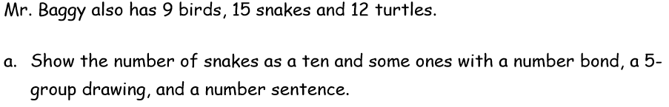

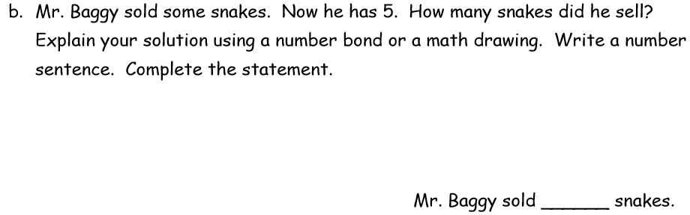

Grade 2 – Module 4: Lesson 31 Problem Set #4

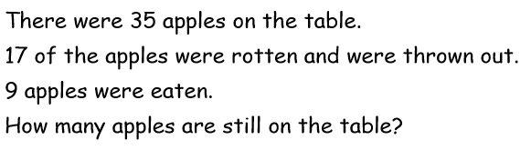

Grade 2 – Module 2: End of Module Assessment

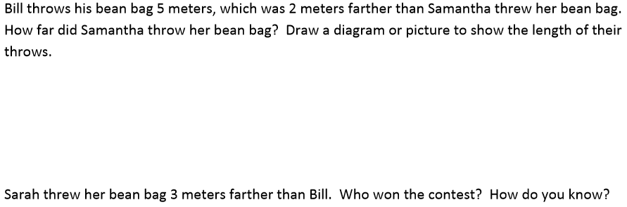

Grade 2 – Module 2: Lesson 10

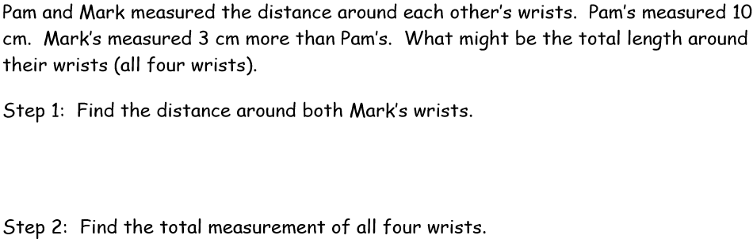

Grade 3 – Module 1: Lesson 21 Problem Set #3

Grade 3 – Module 2: Mid-Module Assessment #3

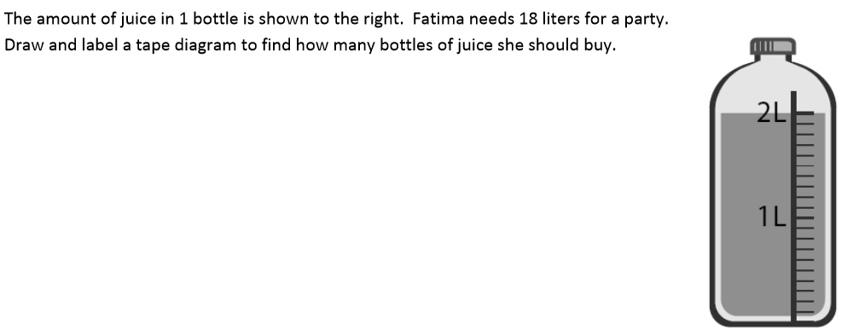

Grade 3 – Module 3: Lesson 18 Problem Set #4 and #5

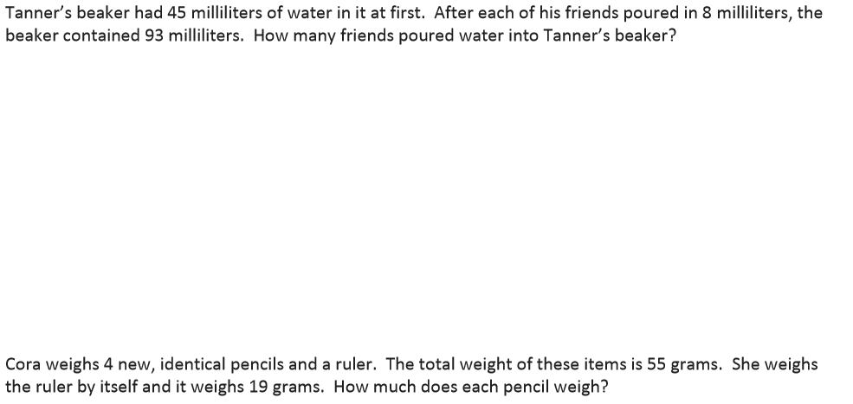

Grade 4 – Module 1: End of Module Assessment #3

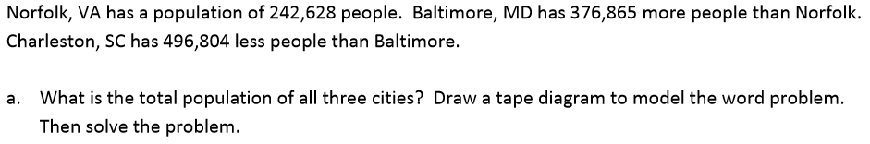

Grade 4 – Module 1: Lesson 19 Homework #2

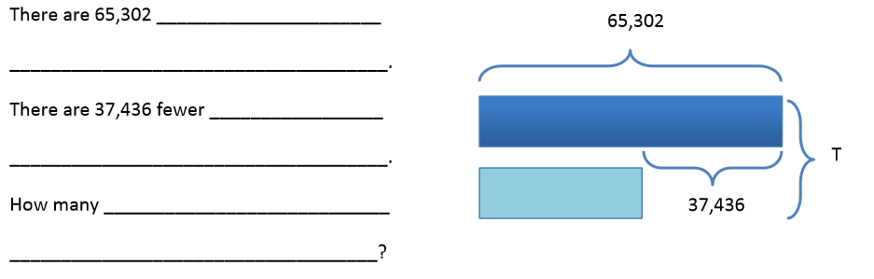

Grade 4 – Module 2: End of Module Assessment #4

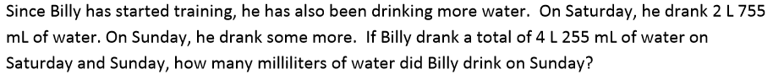

Grade 5 – Module 1: Lesson 16 Problem Set #4

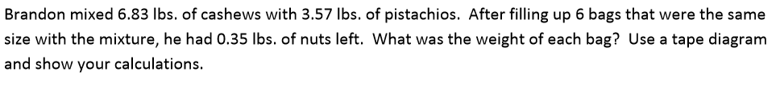

Grade 5 – Module 1: Lesson 14 Problem Set #5

Grade 5 – Module 3: Mid-Module Assessment #1c

