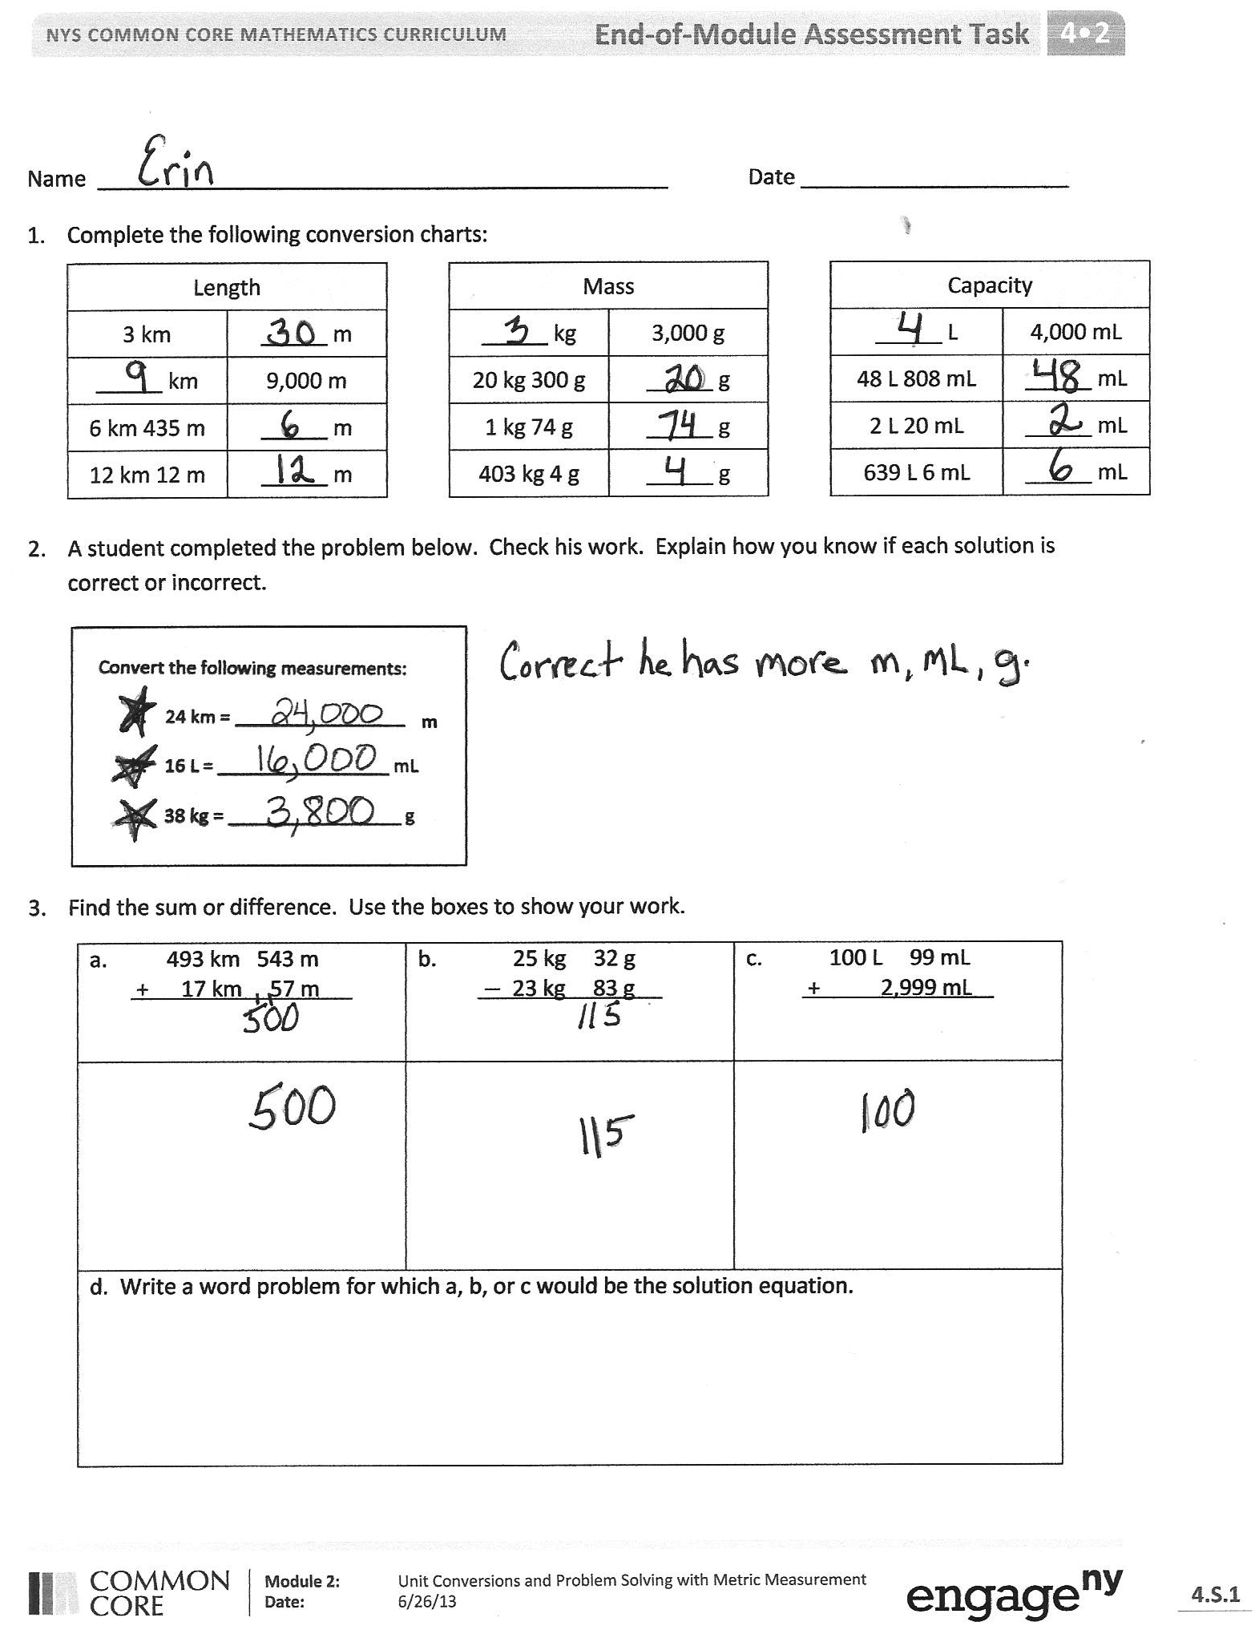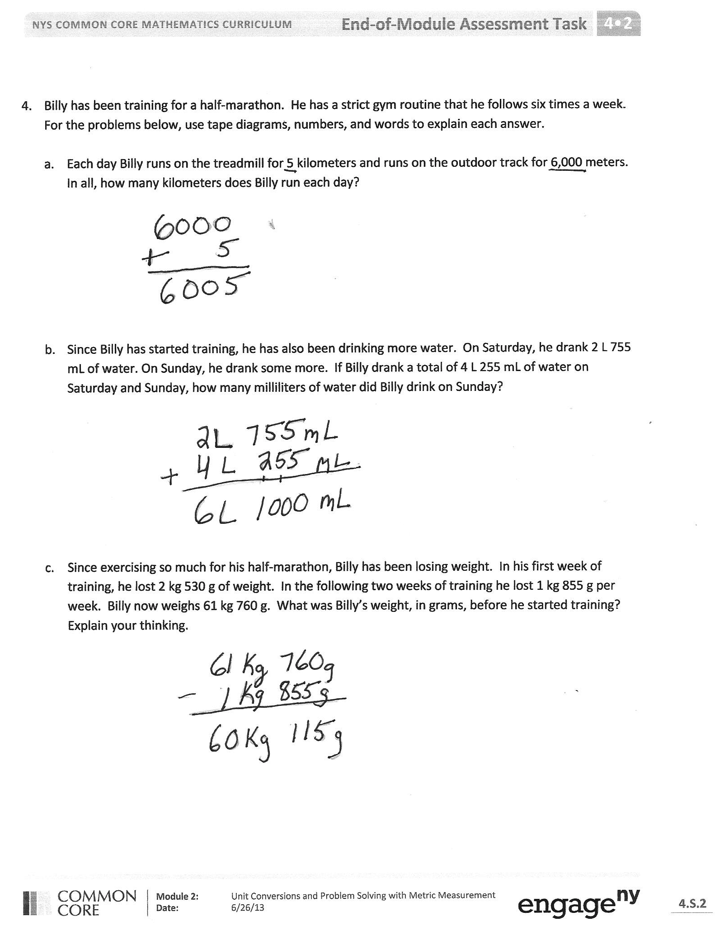

Task 1: _____ Task 2: _____ Task 3: _____ Task 4: _____ Total Points: _____
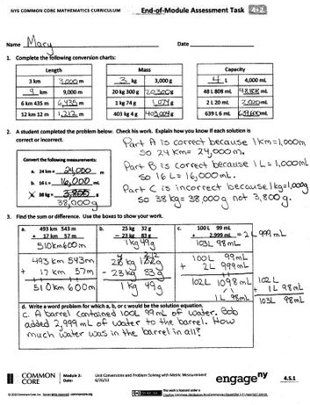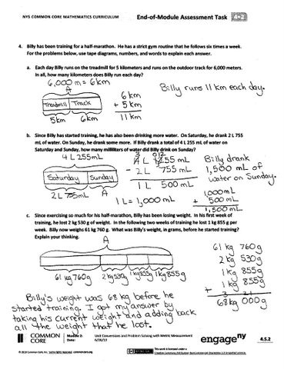

Task 1: _____ Task 2: _____ Task 3: _____ Task 4: _____ Total Points: _____
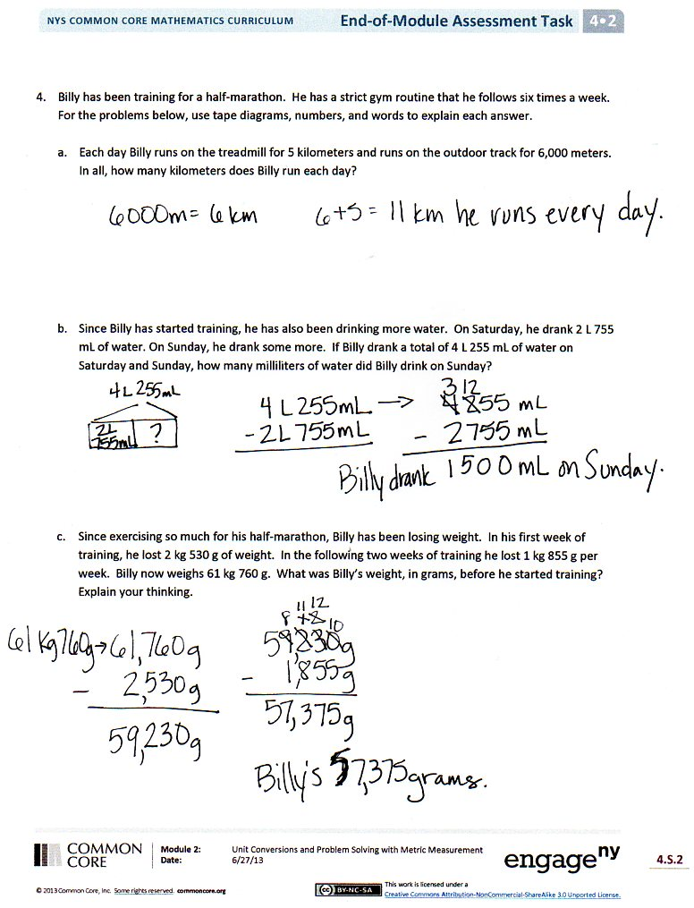
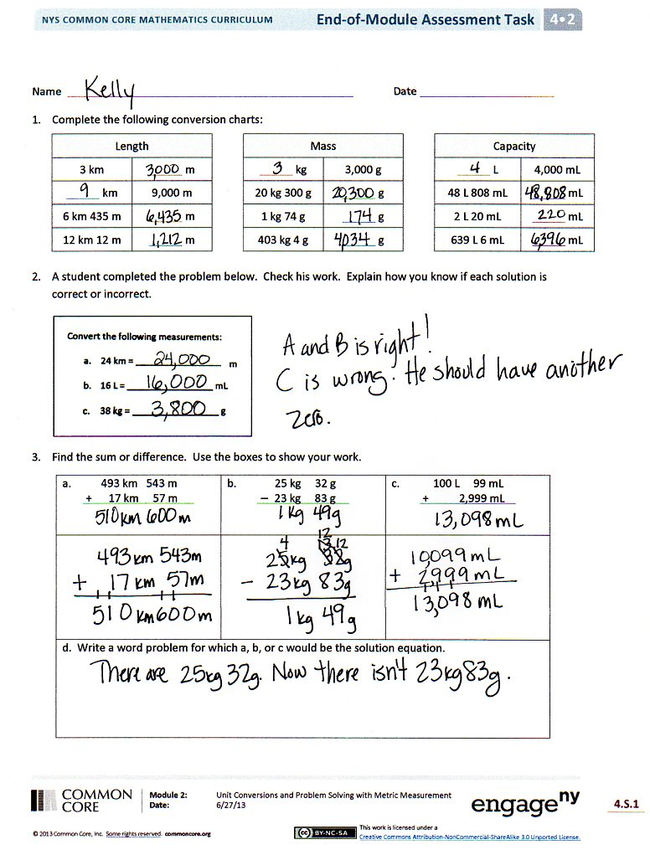

Task 1: _____ Task 2: _____ Task 3: _____ Task 4: _____ Total Points: _____

