Glossary

Table 1. Common addition and subtraction situations.¹

In this first group of problems the operations of addition and subtraction represent motion or change. Objects are coming together or being separated. The information in parentheses is to connect the models to the problem types. A student wouldn’t actually write that information in their model.

 | Result Unknown | Change Unknown | Start Unknown
Add to | Two bunnies sat on the grass. Three more bunnies hopped there. How many bunnies are on the grass now?  2 + 3 = ?  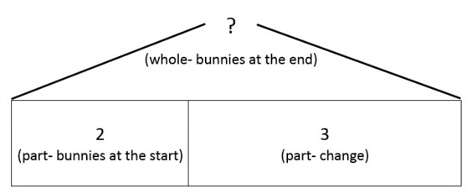 | Two bunnies were sitting on the grass. Some more bunnies hopped there. Then there were five bunnies. How many bunnies hopped over to the first two?  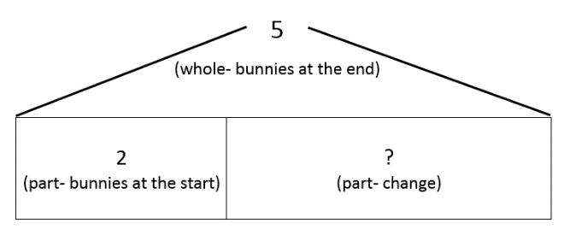  2 + ? = 5 | Some bunnies were sitting on the grass. Three more bunnies hopped there. Then there were five bunnies. How many bunnies were on the grass before?  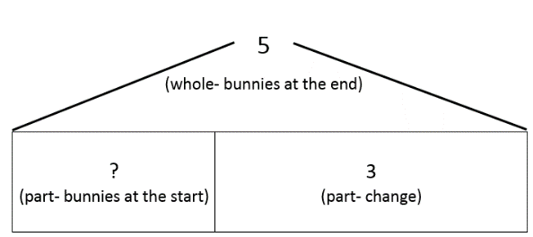  ? + 3 = 5
Take from | Five apples were on the table. I ate two apples. How many apples are on the table now?  5 – 2 = ?  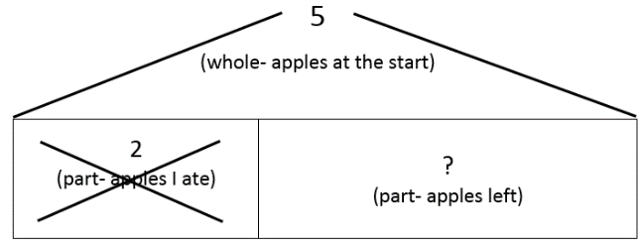 | Five apples were on the table. I ate some apples. Then there were three apples. How many apples did I eat?  5 – ? = 3  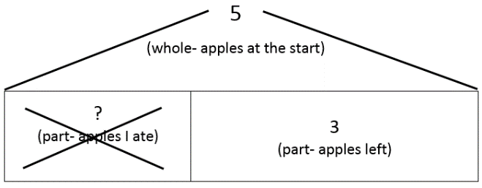 | Some apples were on the table. I ate two apples. Then there were three apples. How many apples were on the table before?  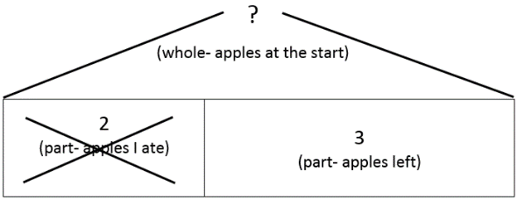  ? – 2 = 3

In this group of problems addition and subtraction are used to understand the parts of a set. Notice that there really isn’t any motion. We are using addition and subtraction to understand the categories within the whole. The information in parentheses is to connect the models to the problem types. A student wouldn’t actually write that information in their model.

 | Total Unknown | Addend Unknown | Both Addends Unknown²
Put Together/  Take Apart³ | Three red apples and two green apples are on the table. How many apples are on the table?  3 + 2 = ?  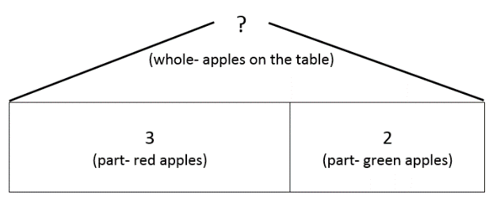 | Five apples are on the table. Three are red and the rest are green. How many apples are green?  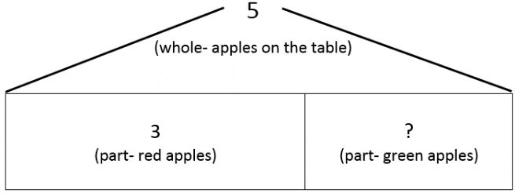  3 + ? = 5, 5 – 3 = ? | Grandma has five flowers. How many can she put in her red vase and how many in her blue vase?  5 = 0 + 5, 5 = 5 + 0  5 = 1 + 4, 5 = 4 + 1  5 = 2 + 3, 5 = 3 + 2  The tape diagrams to represent these combinations are shown below. You may be thinking that number bonds would be a more efficient way to model these combinations. Because a number bond shows part-part-whole thinking it would also be an appropriate tool to model add to, take from, and put together/take apart problems.

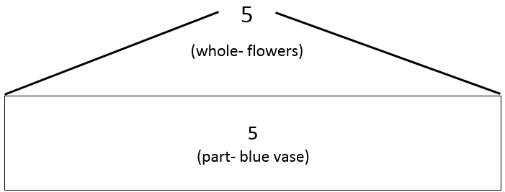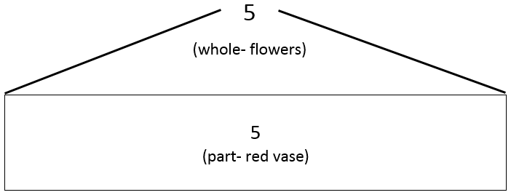

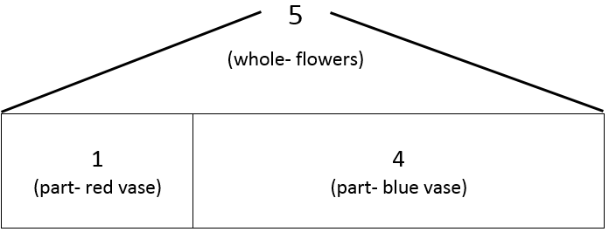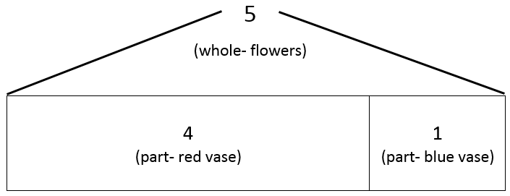

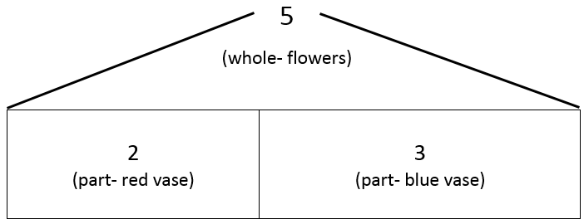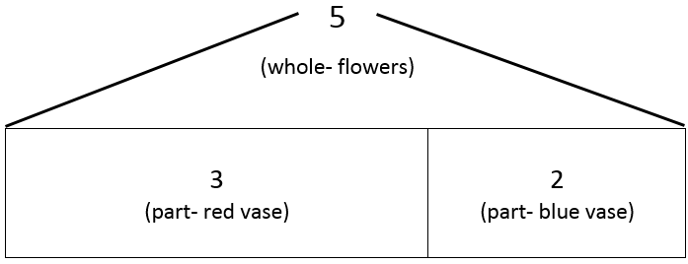
This third group of problems uses additive comparison. Addition and subtraction are used to understand the relationship between two or more quantities. The information in parentheses is to connect the models to the problem types. A student wouldn’t actually write that information in their model. Also, a student could abbreviate the names of the girls as long as they know what “L” and “J” refer to in the problem.

 | Difference Unknown | Bigger Unknown | Smaller Unknown
Compare⁴ | (“How many more?” version):  Lucy has two apples. Julie has five apples. How many more apples does Julie have than Lucy?  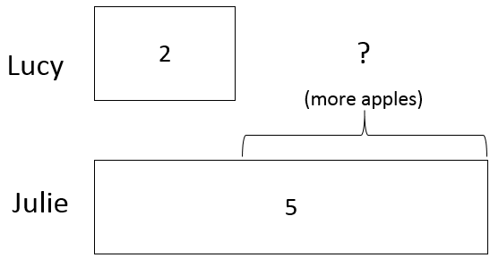  (“How many fewer?” version):  Lucy has two apples. Julie has five apples. How many fewer apples does Lucy have than Julie?  2 + ? = 5, 5 – 2 = ?  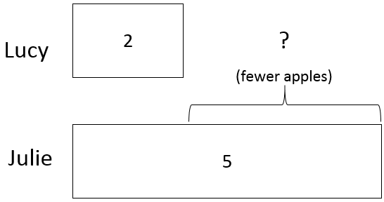 | (Version with “more”):  Julie has three more apples than Lucy. Lucy has two apples. How many apples does Julie have?  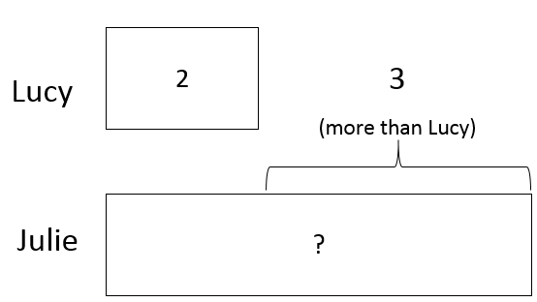  (Version with “fewer”):  Lucy has 3 fewer apples than Julie. Lucy has two apples. How many apples does Julie have?  2 + 3 = ?, 3 + 2 = ?  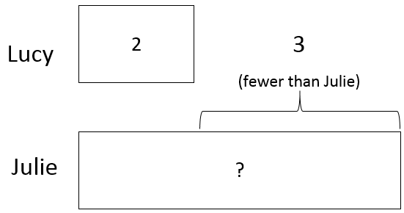 | (Version with “more”):  Julie has three more apples than Lucy. Julie has five apples. How many apples does Lucy have?  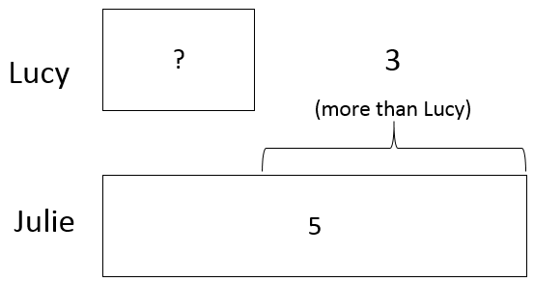  (Version with “fewer”):  Lucy has 3 fewer apples than Julie. Julie has five apples. How many apples does Lucy have?  5 – 3 = ?, ? + 3 = 5  